Presidents Report August 2017
It has been a busy month for the Pre-School, especially with the delightful artist Christabel who has been working so well with the children.
We would also like to take this opportunity to thank Bendigo Bank for their sponsorship of this project. Without their ongoing support, these activities would either cost us a lot more as families or would simply not happen. Please take the time to support the Bendigo Bank in return where you can.
I also need to make a couple of mentions about our brilliant team. Karen and Ann ran a successful conference for our local teaching community on Saturday 12th August at Somers school Camp to support learning around embedding first people’s perspectives into teaching practise and educational communities. Also our amazing chef Mark Heffernan cooked up a selection of soups for the day. He also devoted many hours to the conference, unrequested, to warm and serve soup. This took a large load off Karen and Ann on the day and I know they appreciated his assistance very much so. We also had a couple of other members, Rachel Jacobson and Amelia Bicknell who made a beautiful soup for the occasion. We appreciate the time you took to do this.
As many of you know, I am currently pregnant with twins expected sometime in the next couple of months. With this in mind, I have decided to step aside and allow my brilliant Vice President, Jarna Browne, to take over. I have the hope and intention to return for the AGM in November but of course that will be played by ear. In the meantime, I have no doubt Jarna will do a brilliant job and will be more than happy to assist you where needed.
60 Year Anniversary
We have had a few forms come back in with offers of help, but are still looking for many hands. The more involvement we can have from the families, the more special it will be. We thank you in advance for ANYTHING you are able to contribute.
ENROLMENT DAY!
Please don’t forget Enrolment Day on:
Wednesday 30th August
2:30pm - 4:00pm
This day is for anyone who has been allocated a spot in our 4year old kinder program. Please do not miss this, as your spot will be released back to the council if we do not see you or hear from you.
Please remember you are all welcome to our Committee Meetings as a General Member if you would like to hear more about the comings and goings of the Pre-School.
Next Committee Meeting: 12th September 7pm
Caroline
Djeembana News August 2017
High expectations of every child- the last few weeks have reminded me of the importance of this principle. When we work with children holding high expectations the children demonstrate skills, values, and knowledge that matches their level of development and understanding. Every child is then able to perform to the best of their abilities and experience a strong sense of achievement. An achievement that is not measured, but viewed as a progression and recognised as significant. The Bundjil drawings demonstrate the uniqueness of each child and their individual desire to be part of the project. Each child proudly exhibited their work to their peers and shared their stories story.
Another example of the results of holding high expectations is the competency in which the children have managed the hot glue guns and the wood burner pens. The children have demonstrated recognising the dangers and respecting the safe way to use the equipment.
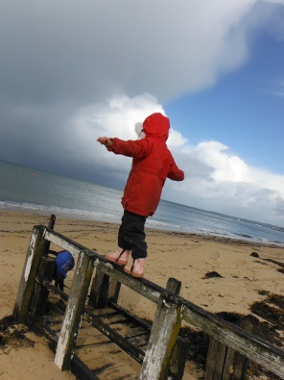
PMP is a program that each weeks extends the skills learnt in the previous week. Every child is experiencing success as they have a go and master another skill and learn about their physical capabilities. With this then comes increased confidence to have a go when the next skill presented appears too hard or presents as a challenge.
PMP skills and confidence put into practice along the old pier at the beach
…This expectation of success is a powerful motivator for children, promoting resilience and willingness to work hard, regulating behaviour and establishing goals and aspirations for the future. High expectations act as an important protective factor in achieving better outcomes for all children including those who encounter more risk and fewer protective factors within their everyday lives. Building on each child’s strengths, and having high expectations for success can help early childhood professionals to reach a unity of purpose around each child and family. (Victorian Early Years Learning and Development Framework)
Early childhood educators who are committed to equity believe in all children’s capacities to succeed, regardless of diverse circumstances and abilities. Children progress well when they, their parents and educators hold high expectations for their achievement in learning. (Early Years Learning framework)
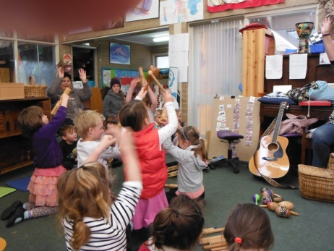
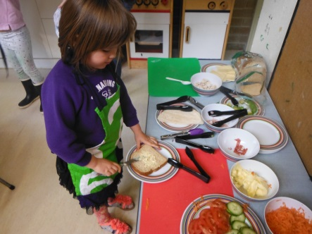
Cooking and food preparation has been popular with the children both inside at the café and outside on the fire. These experiences have taught the children about: hygiene practices; recipes; science concepts when food takes on different forms once cooked; taking different roles (waiters, customers); different ways of cooking; and enjoyment of sharing chatter around food.
Artist project – see Bundjil nest Project section
Music day – The children have demonstrated their enjoyment and interest in music so I have introduced a weekly music session that has a particular structure. Several years ago I completed training in the Orff approach to teaching music, this training guides the development of the music session and its content. There is always an introduction song – How Do you Doodetee. Through this rhyme we are introducing elements of music: beat, volume, pitch and speed. Then there will be the following sections: singing, playing, moving, creating and listening. The children have learnt many new songs and applied their creative movements to dances (Move like a machine) and group movement songs (Cool Cats). Many instruments have been introduced- tambourines, rhythm sticks, maracas, tone blocks and this week tommy drums.
And the Captain looked through his telescope, he looked up high and he looked down low. He looked to the left, and he looked to the right. And what he saw was a wonderful site… he saw some (name instruments) and they (crew)found those instruments. And they played them up high and they played them down low. Then the captain said “Goodbye” because he had to go.
Coming events-
- Artist Wednesday 23rd, children will be designing their own symbol to be placed on the wings of the eagle
- PMP -30th August, 6th Sept, 13th Sept
- Fathers night 5th September 6-7:30. Dinner will be cooked on the fire
- Mothers Night 20th September 6-7:30
- Sunday 27th August 5pm - Opening path and community garden at Balnarring beach concluding with a Bonfire. All families are invited
- 60th Anniversary meeting 29th August 7pm
- Photographer – Group photo 5th September
- Community information day at Balnarring village 16th September 9-1pm
- Friday 22nd September we will be meeting in the carpark at Somers school camp (Lord Somers Road, next to the entrance to Coolart). Parents are welcome to join us for a visit to the camp’s environmental centre. (9:30-11:00). We will then walk back to Balnarring to be collected in our usual space.
Bundjil Nest Project
As you will be aware the children have been working with artist- Christabel- as part of the Bundjil Nest Project. This part of the project also involves preps, grade one and grade two students at Balnarring Primary school and St Jospehs primary school. Please take some time to view the amazing work the children have produced. We thank Balnarring and District Bank for sponsoring Christabel to work with the children.
On 16th September there will be a community information day in the breeze way of Balnarring village. This day is to inform the community of what we have been doing in the project and invite them to the community event in October. Please drop by and share this day.
October 27th is the Bundjil Nest community event to be held at Robertson’s Park at Balnarring beach. On this night the children will parade the Bundjil’s they have made as part of the unveiling of the art piece. Please mark this date in your diaries.

Weelam group: Beerreen News and reflections Term three August 2017
Reflections from our Learning and living with nature experiences:
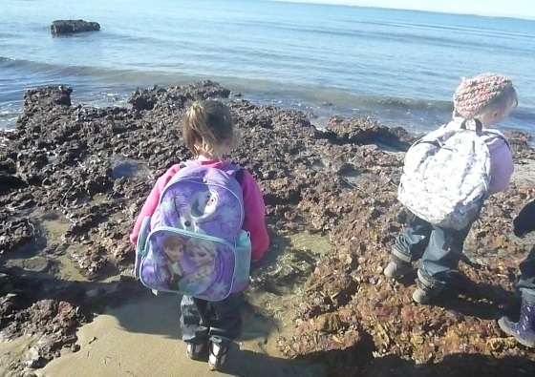
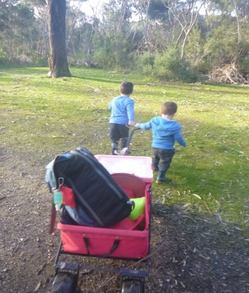
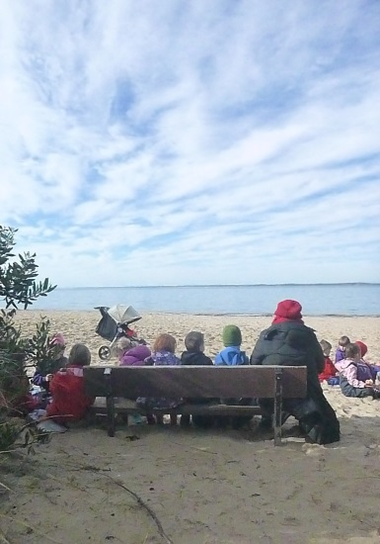
Since returning to term three in Weelam group we have certainly been learning about Beerreen (No more sun, winter) and the changes in our outdoor environments. Over the past month we have experienced firsthand rain, wind, changes in tides, heavier rain, black clouds, clouds that race across the sky, lots of big puddles, waves, sunshine, shadows and rainbows. These experiences connect the children with this Land that we walk on and explore every day. The children are beginning to ‘read’ the weather and understand the changes, two weeks ago we intentionally took the children to the rock pools so they could experience a rising tide, as the waves came in they watched carefully and tried to predict which waves would be the big ones. Each child stood on their rock until the water came to their toes, gradually we watched landmarks and rocks further out disappear as the tide came in. The rising tide moved the children back, and gradually they noticed that there was less sand to play on between the waves and the rock wall.

Last week we took the opportunity while the sun shone to head from bush camp to the beach, how special it was when the children noticed a fin and were able to watch the dolphins swim by. Everyone just stood, watched and waited for them to surface again.
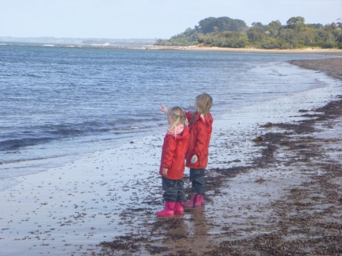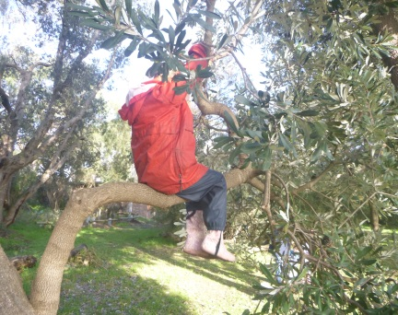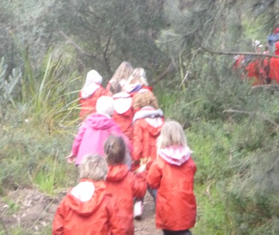
*there are the dolphins!! *a Gurboora up the tree? *off we go on more adventures
We are noticing the changes in the environment, the wattle is beginning to flower, there are fungi that grow after the rain and the holes being dug in the ground, we ask who did that? Who made the hole?
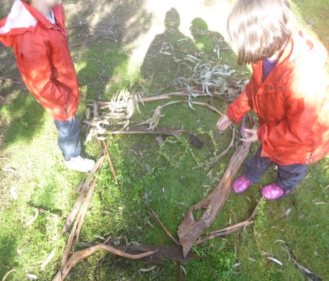
Story telling: Story making and storytelling is included into all areas of our program. While at bush camp and the beach we encourage the children to create stories from the natural materials they find within the environments we visit. I have also been sharing a story told to me by Mrs. Karen about the very old trees being story telling trees.
This week the children noticed that some trees have bar codes and they wondered why??? After exploring possible reasons, it was decided that a bar code meant it was old and therefore a story telling tree. They put their ears to the tree to listen.
As we see very old trees we have been stopping to listen to them and tell each other the story they shared with us about long, long ago. You have to listen carefully…
Friendships: Term three has been a great term for friendships and social development. The children can be observed actively playing in small groups, sharing stories, pretend play games and just chatting together. Our morning tea and lunch times have become wonderful times of conversation between the children and we have been supporting the children to be respectful of each other’s right to join a group, have a turn to speak and to remember to listen while others tell their stories and share their ideas. In particular, we have been intentionally teaching empathy, i.e. developing an understanding for how other may feel, think or feel when they want to do something too. We have been exploring the idea of ‘filling someone’s bucket’, talking about what we can do to make someone happy, to help them and what actions are kind towards someone else. Friendships and relationships can experience many ups and downs, supporting the children to learn ways they can respond, make changes to what is happening, understand another’s perspective and feelings can assist them to problem solve and be responsible when relationships are challenged.
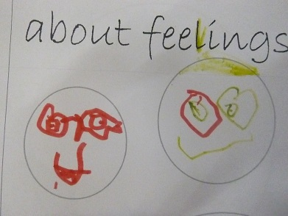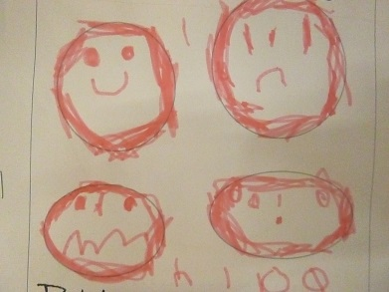
Each child has begun to make their own ‘feelings book’. We are doing this to assist them to understand nonverbal communication of others/ themselves and to become aware of when they feel this way and what they can do if they feel this way. In our books we are exploring feelings beyond happy and sad, discussing scared, excited, angry and loved. We will complete our books throughout this term, then share them with each other and our families.
Students: Please say Hi to the Student Teachers who are joining us for their practicum placements throughout this term. Megan and Nadia have one more week with us and Jacinta will be with us each Monday and Tuesday till the end of term- then she will be with us for the whole of the last week. We will meet Daylene soon. You can help each of the students to develop their skills engaging with families by chatting with them, and asking them about their experiences at the Preschool so far. Engaging with families is an important part of their work and learning towards being a teacher in the future.
Artist in Residency program: Fly Bundjil Fly…Being Artists and Sculptors
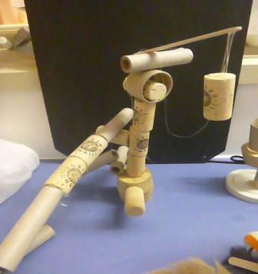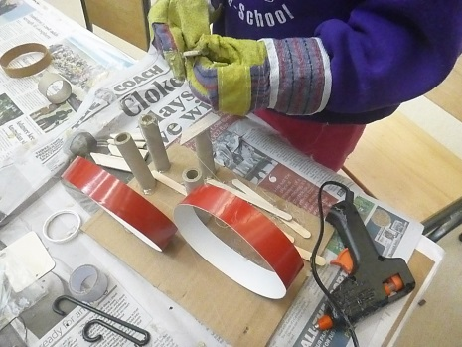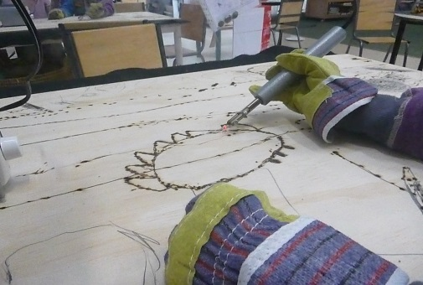
This program has supported the children to learn new skills and work with new equipment tools and materials- soft pastels, glue guns and wood burning tools. They are experimenting and trying new ways to work and explore their ideas in 2D and 3D art works.
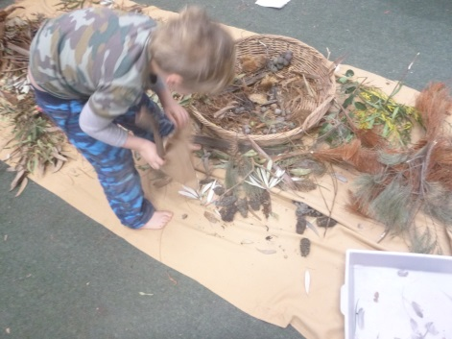
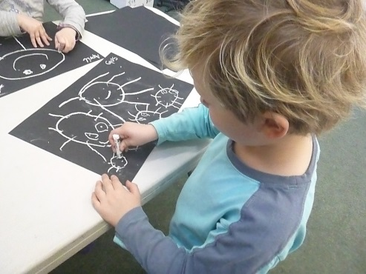
Week One: the children were asked to draw how they saw Bundjil. We then asked the children to tell the story of their picture and to collect natural material for week two to make their Bundjil sculpture.
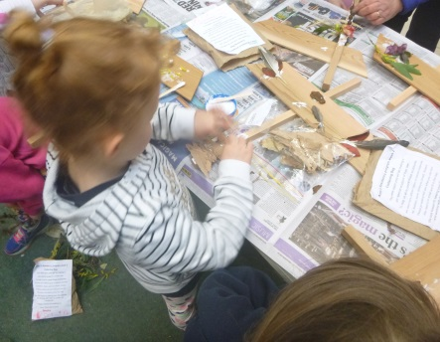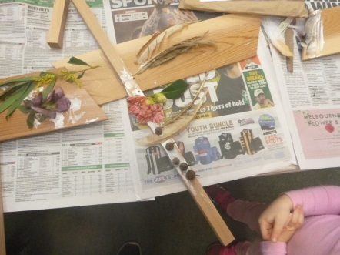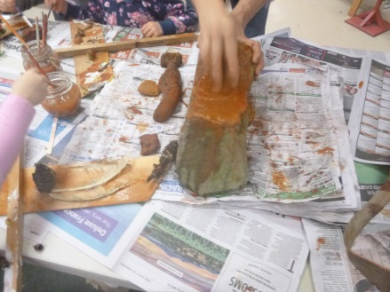
Week two: Each child created their Bundjil using the wooden pieces and natural materials we had all collected. Our Bundjils were painted with the rock paint Christobel (the Artist) showed us how to grind on the big rock and then add water to make paint. This week (week three) we will explore symbols and help create the large sculpture Christobel is making. There is a very special event being planned for October that our Bundjils will participate in.
We thank Balnarring & District Community Bank for their sponsorship of this Artist in residency project. Have you seen the new Bendigo Bank Community sign we helped to create? On a very windy day down on the beach we manage to organize and hold onto all the letters to spell the word COMMUNITY - with the help of the yellow pig!!!
Fire: Learning about ‘Good fires’ and how to be safe around fire
We are learning that fire can be used for cooking, keeping warm and share stories around
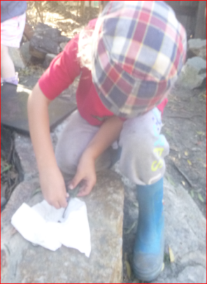
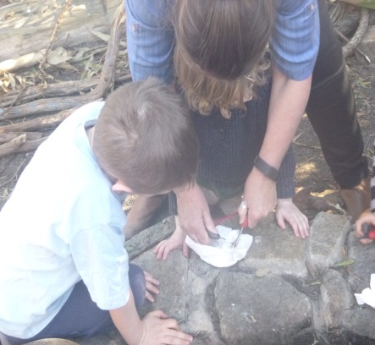
Finally, the strong winds disappeared so we could light the campfire and cook our sausages. The children and myself were challenged to light the fire without matches. Using the flints and with perseverance we did it!! The campfire supports the children to engage with fire as ‘good fire’ and to learn to respect why and how to use fire safely. We shared the sausages with each other…yum.
Watching Seeds, Cuttings and Bulbs growing:
Over the past two months we have been watching the bulbs in our vase and the geranium cuttings in water to see the changes as they grow. The bulbs have grown roots, leaves and are now flowering. We have documented their growth in our book about daffodils (see our pictures in the book beside the vase). We have also started growing lawn seeds in little pots- many children are now bringing them in to show us how tall the grass has grown. Now we are going to try and make a hairy green caterpillar. Keep watching to see what happens.
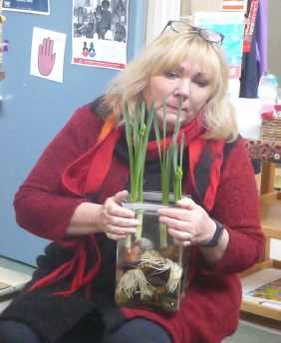
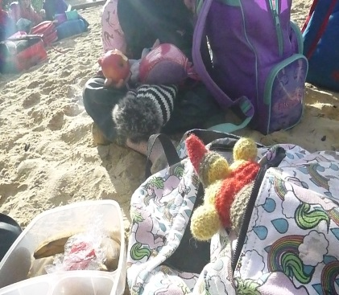
CoCo (our group mascot) has visited many Weelam group friends staying over for a few nights at their homes and going on many adventures. Recently CoCo joined us at Bush camp and sat with us as we had morning tea on the beach together. Each day when CoCo returns we hear the stories of CoCo’s visit to our Weelam group friends home and we look at their picture of CoCo and any photos too. p.s. CoCo can be a male of female – it is up to the child to choose.

Jemma’s news: The group was very excited to receive news and photos from Jemma as she and her family venture up to the top of Australia. She told us she saw 100 whales!!! We have put her email in the group diary and are adding a map so we can watch Jemma’s progress there and back. Feel free to take a look at our diary to see Jemma’s news, photos and stories.

Pattern Making and exploring shapes: Developing literacy and numeracy skills in play. How do you make a circle join up or with straight lines?
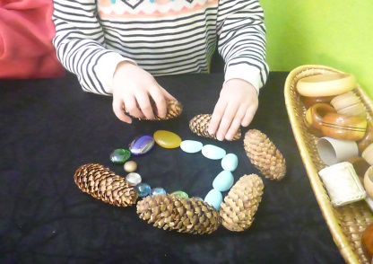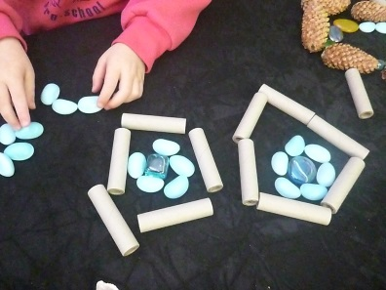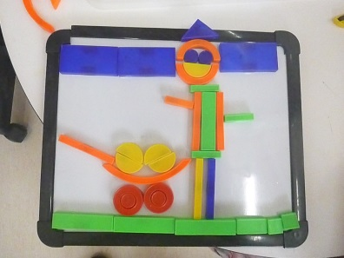
Currently we are exploring shapes and pattern making in new many ways. We are exploring the ways they join together, the sequences we can create, the names of each shapes and the shapes we need to make our pictures and tell a story.
Important dates and upcoming events: As we move into the second half of term three (yes we have only five weeks left) we have many experiences planned for your child and for your family to participate in. Please put these dates in your diary.
- Kindergarten Photographer will be taking our Weelam Group photo
on Tuesday 5th September
(Individual photos of the children will then be taken in term four)
- Excursion to Somers school camp Environmental centre:
Wednesday 20th September
Somers School Camp

- VIP nights: Keep watching for your invitations for our VIP/ family / Grandparent events that will be organized before the end of term.

- PMP: Thursday 31st September (please see the roster-we appreciate your help).
Thursday 7th September (Outdoor Class day)

Thursday 21th September (Last day of term)
Can you help with Wood for our Camp fire: We now have our wonderful new wood/ cooking shed down by the campfire? We would appreciate if you have small pieces of dry fire wood and logs to bring them in so we can now fill our wood shed and continue our cooking experiences. All donations of wood appreciated. Please see Ann if you can help.
Thank you for your ongoing support and times helping within the program. It is always a special time for your child when you join us for a session. Please ask for a time to chat if you have any questions about the programs and the move to school next year.
Kind regards, Ann and Michele

Manameet and Gareeal - August News
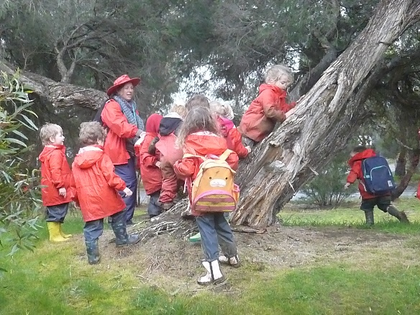
The 3-year-old groups have had a very busy end to term 2 and start to Term 3. Their confidence and ownership over the space and their learning is clearly evident as the independently explore and show wonder in their environment and activities.
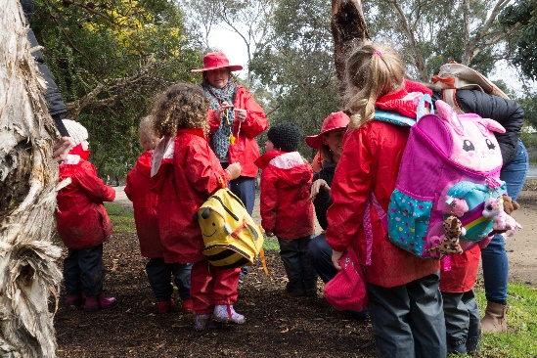
We celebrated the end of term 2 with Mud Day and children engaged, created, jumped, painted, moulded, slid and threw mud. Children were encouraged to participate at a level they were comfortable with and had lots of fun doing so… as we all did! Thank you to all of the families who joined us on the day and helped to make it special. We also appreciated the yummy hot chocolate and marshmallow treat at the end! Celebrating mud day together provided the opportunity to strengthen children’s sense of belonging, wellbeing and identity.
Children have jumped right into Term 3, enjoying the change to the room layout and exploring it inquisitively. Following some children’s interests, we have begun working on creating special cuddle toys. Our first step has been to stuff the toy (sock) which allows the children to strengthen their dexterity through fine motor practice as they tear the stuffing and pack it and manipulate elastic bands to hold the stuffing in where they choose. They have thought creatively, planned and practiced language skills as we use a traditional Indigenous activity of yarning as we work. Together, we have discussed the task and what the children would like to make as well as take our time to yarn and chat about life and anything that we wish. It has been a wonderful opportunity for us to spend high quality time with the children.
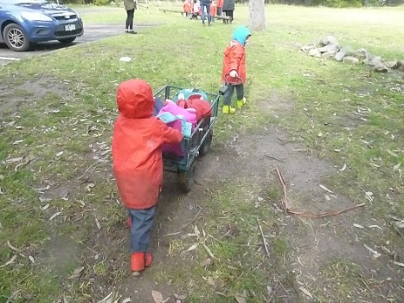
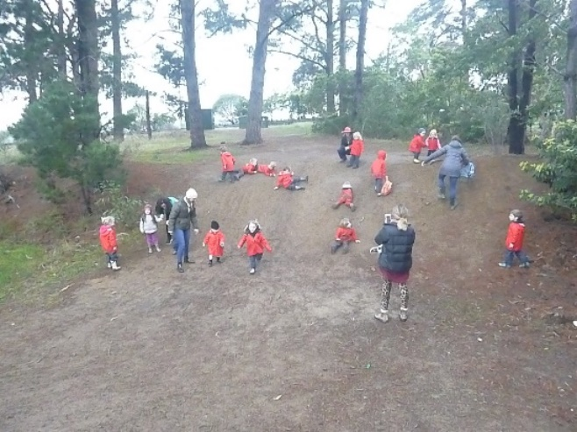
We have also been on our first wetlands walk for the year. Again, the family support has been wonderful for both three year old groups with lots of you managing to join in the fun with us. Neither group actually made it to the wetlands on the walk, the freedom of running and sliding and exploring the pine forest, climbing the climbing trees, searching for witchy fingers and jumping and running in puddles was too great! The children definitely enjoyed their time outside in nature and followed the safety protocols we put in place with the children. These adventures help to develop children’s resilience and gross motor skills, expands vocabulary as we explore and wonder and helps children develop learning skills which will help them in the future such as persistence, risk taking, team work and curiosity just to name a few. The children also took turns to push our trolley on the walk with us, problem solving together and cooperating to manoeuvre it safely. We listened at various times for Waa and Bundjil on our walk on Boon Wurrung country. We heard Waa but not Bundjl this time.

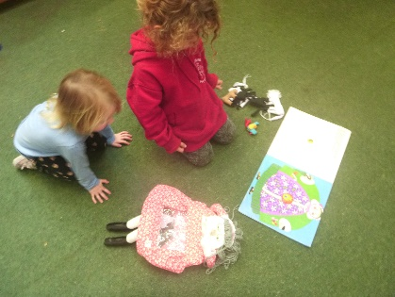
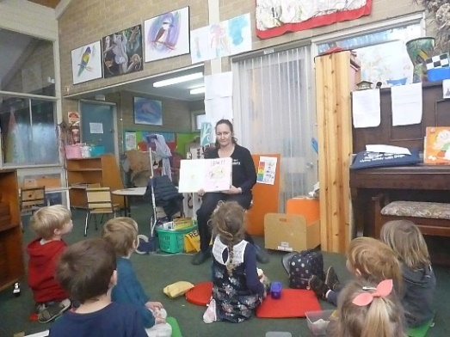
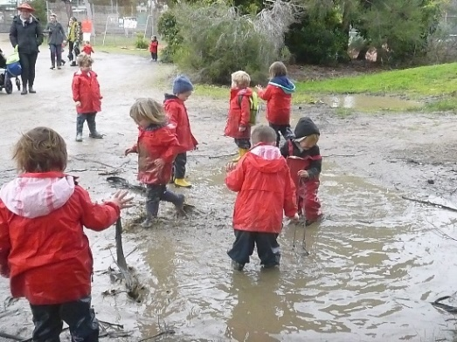
Mornington Peninsula library came to visit the three old groups recently. Tania spoke to the children about the library services, read some stories and sang a song. The children all received a free bag and book to take home.
Some other things we have enjoyed in our sessions have been the bikes and balls outside. These are great for our gross motor skills, particularly when we ride on the grass and really activate those deep muscles! We have begun creating a story shelf, where children have the opportunity to act out and retell familiar stories. This is beneficial for their literacy skills and allows them to engage with new and familiar words assisting to build their vocabulary and language skills. Children have also been role playing in our doll washing / caring play space and outside in the cubby cafe. Again, great for literacy skills and assists children to make sense of the world around them as they enact and role play different roles and experiences they see in their lives and community. Outside we have continued to care and explore the vegetable garden. We found radishes so we picked some, cut some up and even tried them. We talked about safely using the knifes, took turns and had some interesting conversations about radishes. We also spent time exploring cooking ingredients like flour. We sifted, moulded and drew in it. We were using our senses to explore, smell, touch and sight and enjoyed talking about the texture and describing the powder floating in the air.
Coming Soon
- Parent / Teacher Interviews are coming up on the 30th August and 5th September. Please come to speak to me if you are unable to make these dates and wish to arrange a time.
- During our session on the 25th August we will be going on another wetland walk.
- Steph a lovely mum from Manameet Group is doing a very special yoga incursion for us on the second last week of term.
Clothing Reminder
Please ensure you child is dressed appropriately for cold weather and has a complete change of clothing including underwear and socks in their bags. If your child comes in gumboots, please make sure they have a pair of shoes or slippers to change into when we come back inside.
Stay and Play
Thank you to the families who have again stayed and played over the past couple of months. Your presence and contribution to the program and session is much appreciated by children and staff! I would also like to thank Sian, Leni’s mum and Leni’s grandmother from Gareeal for organising and making an impressive laundry bag for the 3 year old groups. We are very lucky to have such thoughtful and helpful families at the Preschool and we thank you very much. Thanks Jill and Cath

PS This month I have added some practical information form the Raising Children Network website for parents regarding behaviour. A few parents have approached me regarding behaviour concerns they are seeing in their child. The information below offers some practical suggestions you can try. Unfortunately, there is not one golden solution and it’s often a case of trying different things to see what works best for your family. There are also some great resources and books in the kinder foyer which you are welcome to borrow. Parenting is certainly tricky and hard work. As a teacher, I will look to the environment and myself to see what I can change that might be causing or intensifying certain behaviours so things like timing, routines, activity and noise. My advice as a parent going through the same thing is to remember to laugh (even though you want to cry or scream) and not to be too hard on yourself, it’s OK to have a bad day we all have them.
TIP: Through my professional development I have come across a great free app called the smiling mind app. It’s a modern meditation app that has various programs even short ones for young children to help improve health and wellbeing. Definitely worth a look.
Try our practical tips to encourage the behaviour you want in your child.
You can read this article in a selection of languages other than English.

How to encourage good behaviour in your child
A positive and constructive approach is often the best way to guide your child’s behaviour. This means giving your child attention when he behaves well, rather than just applying consequences when he does something you don’t like.
Here are some practical tips for putting this positive approach into action.

Tips for good behaviour
1. Be a role model
Use your own behaviour to guide your child. Your child watches you to get clues on how to behave – and what you do is often much more important than what you say. For example, if you want your child to say ‘please’, say it yourself. If you don’t want your child to raise her voice, speak quietly and gently yourself.
2. Show your child how you feel
Telling your child honestly how his behaviour affects you helps him see his own feelings in yours. And if you start sentences with ‘I’, it gives your child the chance to see things from your perspective. For example, ‘I’m getting upset because there is so much noise that I can’t talk on the phone’.
3. Catch your child being ‘good’
When your child is behaving in a way you like, give her some positive feedback. For example, ‘Wow, you’re playing so nicely. I really like the way you’re keeping all the blocks on the table’. This works better than waiting for the blocks to come crashing to the floor before you take notice and say, ‘Hey, stop that’.
This positive feedback is sometimes called descriptive praise because it tells children specifically what they’re doing well. Try to make six positive comments for every negative comment. And remember that if children have a choice between no attention or negative attention, they’ll often seek out negative attention.
4. Get down to your child’s level
When you get close to your child, you can tune in to what he might be feeling or thinking. Being close also helps him focus on what you’re saying about his behaviour. If you’re close to your child and have his attention, you don’t need to make him look at you.
5. Listen actively
To listen actively, you can nod as your child talks, and repeat back what you think your child is feeling. For example, ‘It sounds like you feel really sad that your blocks fell down’. When you do this, it can help young children cope with tension and big emotions like frustration, which sometimes lead to unwanted behaviour. It also makes them feel respected and comforted. It can even diffuse potential temper tantrums.
6. Keep promises
When you follow through on your promises, good or bad, your child learns to trust and respect you. She learns that you won’t let her down when you’ve promised something nice, and she also learns not to try to change your mind when you’ve explained a consequence. So when you promise to go for a walk after your child picks up her toys, make sure you have your walking shoes handy. When you say you’ll leave the library if your child doesn’t stop running around, be prepared to leave straight away.
7. Create an environment for good behaviour
The environment around your child can influence his behaviour, so you can shape the environment to help your child behave well. This can be as simple as making sure your child’s space has plenty of safe, stimulating things for him to play with. Make sure that your child can’t reach things he could break or that might hurt him. Your glasses look like so much fun to play with – it’s hard for children to remember not to touch. Reduce the chance of problems by keeping breakables and valuables out of sight.
8. Choose your battles
Before you get involved in anything your child is doing – especially to say ‘no’ or ‘stop’ – ask yourself if it really matters. By keeping instructions, requests and negative feedback to a minimum, you create less opportunity for conflict and bad feelings. Rules are important, but use them only when it’s really important.
9. Be firm about whining
If you give in when your child is whining for something, you can accidentally train her to whine more. ‘No’ means ‘no’, not maybe, so don’t say it unless you mean it.
10. Keep things simple and positive
If you give clear instructions in simple terms, your child will know what’s expected of him – for example, ‘Please hold my hand when we cross the road’. And positive rules are usually better than negative ones, because they guide your child’s behaviour in a positive way. For example, ‘Please shut the gate’ is better than ‘Don’t leave the gate open’.
11. Give children responsibility – and consequences
As your child gets older, you can give her more responsibility for her own behaviour. You can also give her the chance to experience the natural consequences of that behaviour. You don’t have to be the bad guy all the time. For example, if it’s your child’s responsibility to pack her lunch box and she forgets, the natural consequence is feeling hungry at lunch time.
At other times you might need to provide consequences for unacceptable or dangerous behaviour. For these times, it’s best to ensure that you’ve explained the consequences and that your child has agreed to them in advance.
12. Say it once and move on
If you tell your child what to do – or what not to do – too often, he might end up just tuning out. If you want to give him one last chance to cooperate, remind him of the consequences for not cooperating. Then start counting to three.
13. Make your child feel important
Give your child some simple chores or things that she can do to help the family. This will make her feel important. If you can give your child lots of practice doing a chore, she’ll get better at it, feel good about doing it, and want to keep doing it. And if you give her some praise for her behaviour and effort, it’ll help to build her self-esteem.
14. Prepare for challenging situations
There are times when looking after your child and doing things you need to do will be tricky. If you think about these challenging situations in advance, you can plan around your child’s needs. Give him a five-minute warning before you need him to change activities. Talk to him about why you need his cooperation. Then he’s prepared for what you expect.
15. Maintain a sense of humour
It often helps to keep daily life with children light. You can do this by using songs, humour and fun. For example, you can pretend to be the menacing tickle monster who needs the toys picked up off the floor. Humour that has you both laughing is great, but humour at your child’s expense won’t help. Young children are easily hurt by parental ‘teasing’.

Fundraising Report August 2017
Hello wonderful families, the year is flying and it’s hard to believe we are already half way through the third term!!!
ART ON A PLATE
Art on a Plate has been a great success, with lots of interesting pictures being created by our budding artists! We can’t wait to see the finished products.
BUNNINGS BBQ
A HUGE thank you to all the families who helped run our Bunnings BBQ. We made a massive profit of over $900 and our wonderful volunteers battled the elements to keep the sausages cooking. It is only through your generous donations of time, that enables us to run the BBQ, so thank you so much!
CUSTOM PRINTED BAGS
Custom printed bags will be next on our agenda, and make great library bags, enviro shopping bags or Christmas gifts for grandparents. We will be sending forms out in September for purchase to allow adequate time for turnaround before Christmas.
SUSTAINABILITY FAIR
We are holding a pre-loved children’s clothing stall at the Balnarring Primary School on Saturday 14th October. There will be a donations bag set up in the foyer for clothing (babies – 12 year olds), books and sustainable toys. We do ask that all donations for this event please be in very good condition. Closer to the date we will happily welcome any volunteers to help sort the donations and run the stall.
Thanks again for your time, generosity and positive attitudes,

Rachel Jacobson
Fundraising Coordinator
Balnarring Pre-School
0407 527 609
charlbella@outlook.com

SEEKING COMMUNITY INVOLVEMENT
In 2018 the Bundjil nest community event is being replaced by a full day festival –
Womindjeka Balnarring Ngargee (festival). The festival committee comprises people from the community and are looking for more people. As you can imagine this is a huge event to plan and run. The following sub committees are looking for more help: Children’s area; entertainment; food; market area; advertising; wellness area; fundraising; general assistance.
Can you help out? Do you know someone else who might be interested?
Next meeting 22nd August 6pm at the kindergarten
If you are interested in being involved, please see Karen or Ann.

PARENT LIBRARY
In the foyer there are assortments of books covering various topics that are available for parents to borrow.
One section is dedicated to the developing knowledge about the culture of the First Peoples. If you are interesting in learning about the history of the Aborigines and sharing stories with your children then please take at look at these books.
Boon Wurrung Language
Garwarn –Echidna
Teerrendeer – Eggs
Galk – Stick
Burrun-bul – Ants
Dulaiwurrung – Platypus
Turror – Worms
Bung gang gulum - Yabby
Permission has been granted by Elder Fay Stewart-Muir and Arweet Carolyn Briggs.

Book swap boxes
In the foyer there is a book stand provided by Peninsula reads. Children are invited to take a book from this stand and share with their families at home. This book is theirs to keep.
The book swap boxes and stands have been placed all over the Peninsula in various public spaces e.g. Centrelink, Peninsula Community health, Maternal child health centres, Balnarring Laundry Mat. Your child can take a book from any of these boxes/stands.
When you have books that are no longer being used in your home please donate them back to the book boxes/stands

